

GOVERNMENTOFANDHRAPRADESH
GVWV&VSWSDEPARTMENT
Auto Nagar, Vijayawada

USER MANAUAL
FOR
ONLINE SUBDIVISION

Contents
Procedure for applying the Request at GSWS End: - 3
Figure 1: Logging in 3
Figure 2: User Id 4
Figure 3: Password 4
Figure 4: MeeSeva Services 5
Figure 5: Selection of department 6
Figure 6: Selection of service 7
Figure 7: Request Screen 8
Figure 8: Land parcel details 9
Figure 9: Sub division details 9
Figure 10: Land boundary owner details 9
Process Flow: 12
Procedure at VILLAGE SURVEYOR End: 12
Figure 1: MeeSeva website 12
Figure 2: Selecting Login 12
Figure 3: Login and Password 13
Figure 4: Login and Password 13
Figure 5: Search criteria 13
Figure 6: List of application 14
Figure 7: Service request details 15
Figure 8: Documents 15
Figure 9: Message to applicant 16
Figure 10: Notice generation 16
Figure 11: Notice generation Date and Time 16
Figure 12: Notice 17
Figure 13: Action Taken 17
Figure 14: Documents Upload section in VILLAGE SURVEYOR Login 18
Figure 15: Upload procedure 18
Figure 16: Document Preview 18
Figure 17: Remarks and Forward to MANDAL SURVEYOR option 19
Figure 18: Message preview 19
MANDAL SURVEYOR-End: 20
Figure 19: MeeSeva website 20
Figure 21: Selecting Login 20
Figure 22: Login and Password 21
Figure 23: Login and Password 21
Figure 24: Search Criteria 21
Figure 25: List of applications 22
Figure 26: Service Request Details 22
Tahsildar -END 23
Figure 27: MeeSeva website 23
Figure 28: Selecting Login 23
Figure 29: Login id and password 24
Figure 30: Selection of service 24
Figure 31: Search Criteria 24
Figure 32: List of applications 25
Figure 33: Service Request Details 25

ONLINE SUB DIVISION
This Service is mainly used for measuring boundaries of field by Surveyor. Online Subdivision Service is mainly used for subdivision of land based on citizen`s request. Online Subdivision is done by Village Surveyor. The citizen needs to approach GSWS franchise for applying online subdivision. The issuing authority of Online Subdivision Service is Tahsildar.

Process Flow: Digital Assistant -----> VILLAGE SURVEYOR----->MANDAL SURVEYOR----->Tahsildar.

Procedure for applying the Request at GSWS End: -

This section contains instructions for the users to apply for Online Subdivision from GSWS / VSWS website. This service is meant for online sub division service in Re Survey completed villages only.

- Go to GSWS website and select on Login as depicted in Figure1.

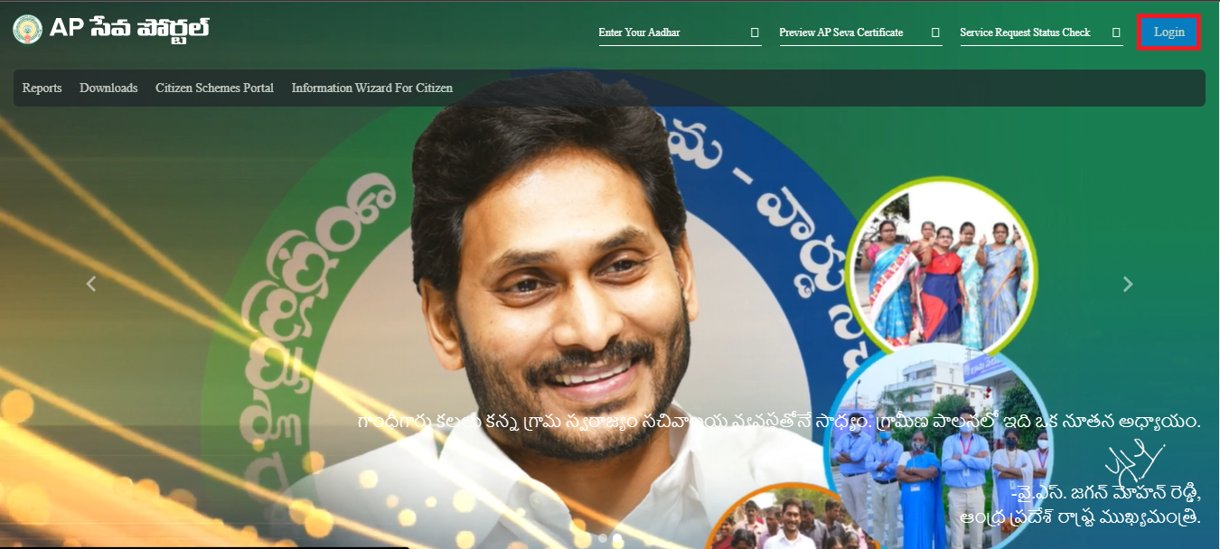

Figure 1: Logging in

- Enter User id and select next as depicted in Figure 2.
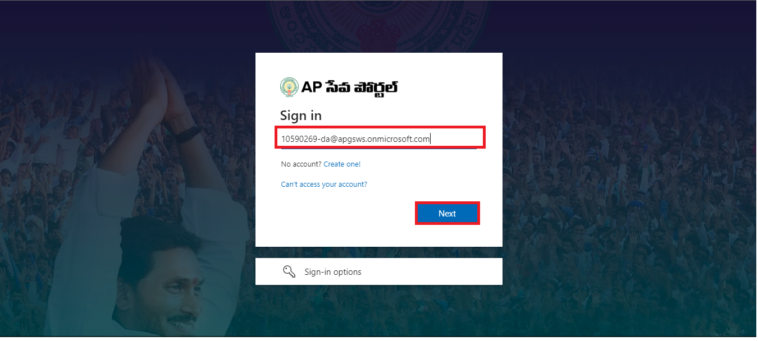

Figure 2: User Id

- Enter password and select on Sign in as depicted in figure 3.
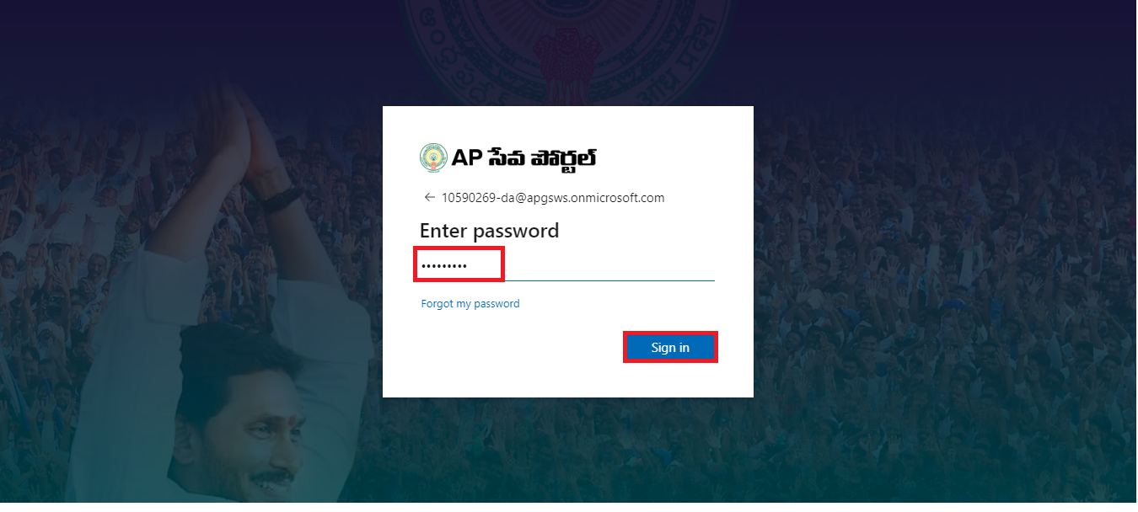

Figure 3: Password

- A screen will appear and select MeeSeva Services as depicted in figure 4.

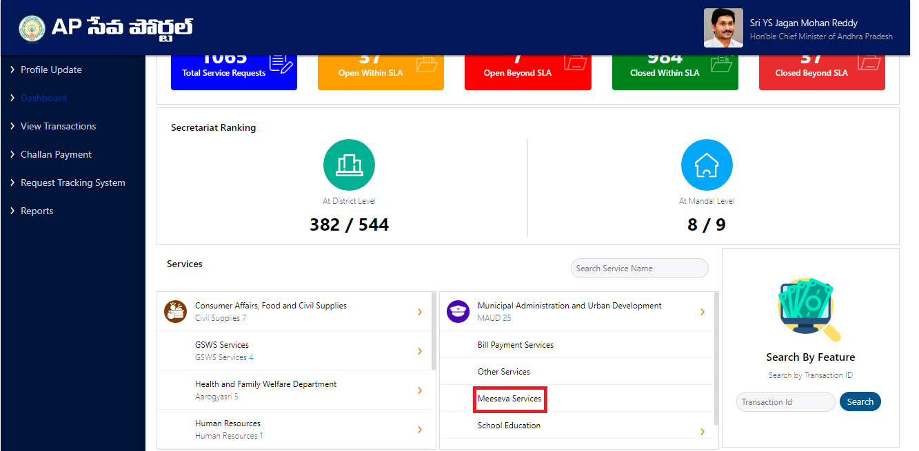

Figure 4: MeeSeva Services

- A list of services will appear in that list select REVENUE department as depicted in figure 5.
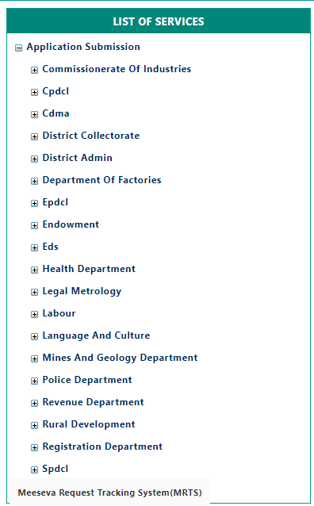

Figure 5: Selection of department

- Select Online Subdivision service as depicted in figure 6.

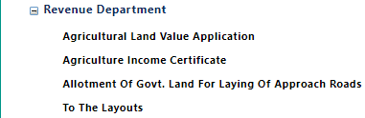


Figure 6: Selection of service

- A request screen will appear as depicted in figure 7.

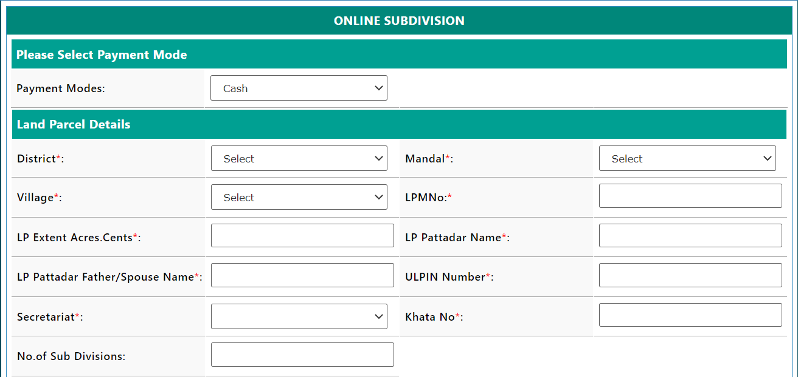
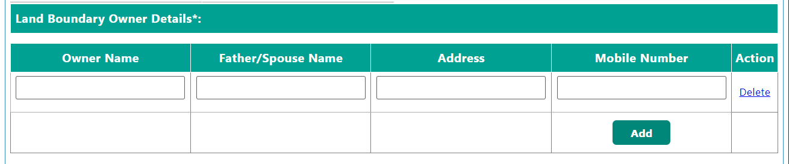
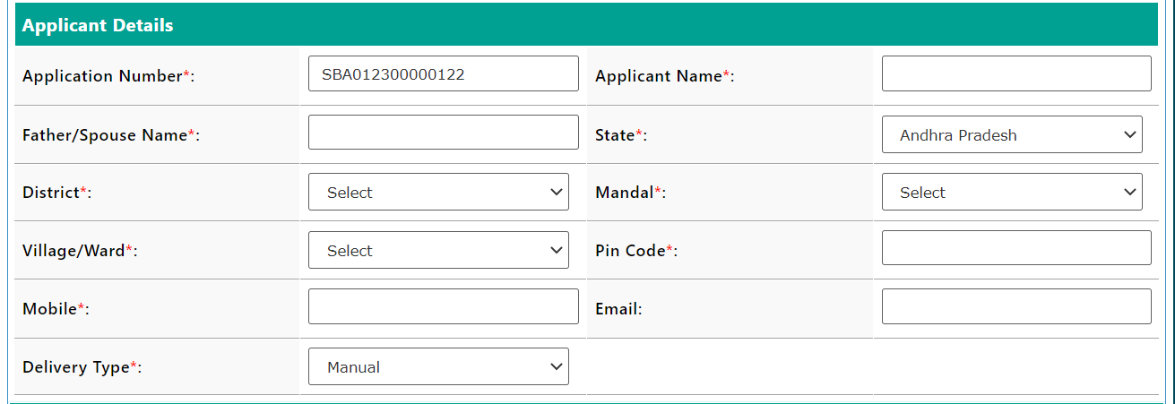
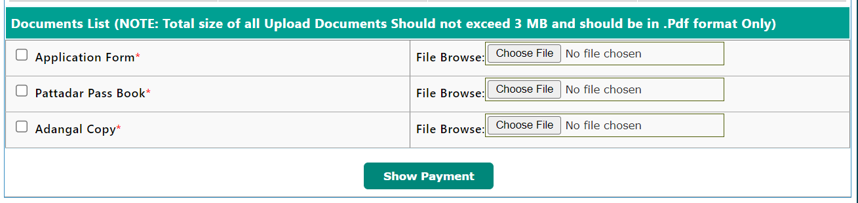

Figure 7: Request Screen

- Enter land parcel details such as District, Mandal, Village, LPM no., LP extent acres. Cents, LP pattadhar name, LP pattadhar father/ spouse name, ULPIN number, Secretariat, khata number and no. of sub division as depicted in figure 8.
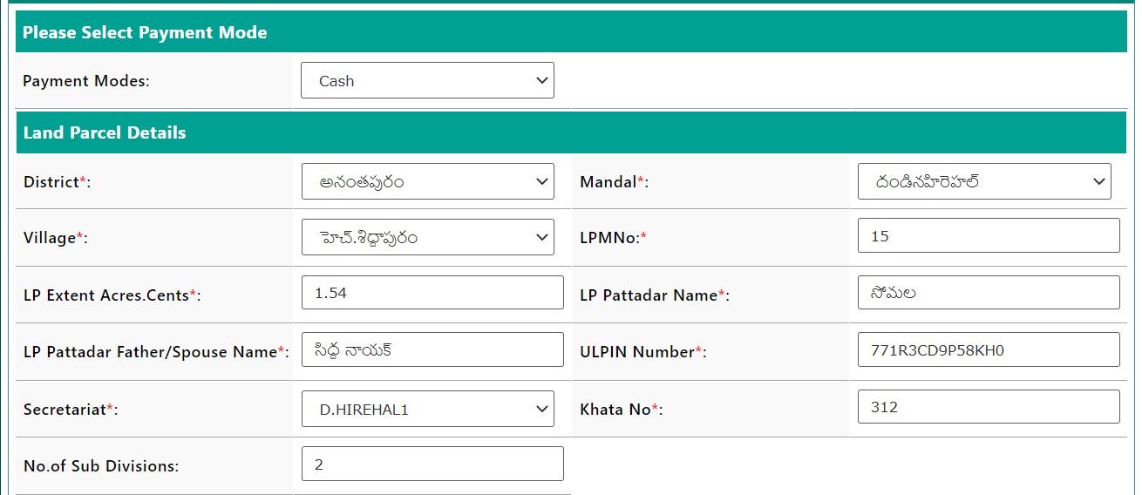

Figure 8: Land parcel details

- Enter sub division details such as proposed new LPM and Extent as depicted in figure 9.

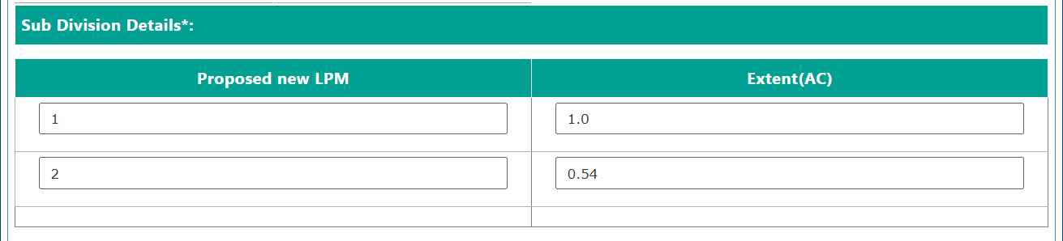

Figure 9: Sub division details

- Enter Land boundary owner details such as owner name, Father/ spouse name, Address and mobile number as depicted in figure 10.

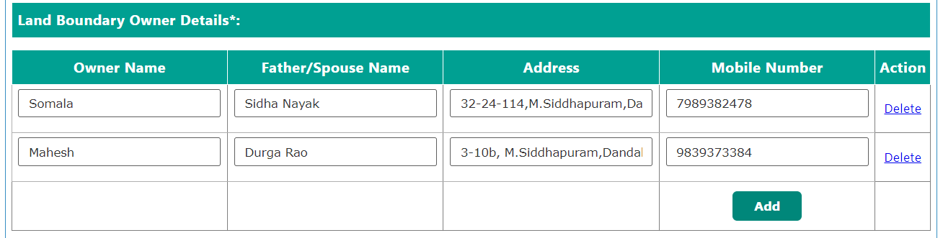

Figure 10: Land boundary owner details

- Enter applicant details such as application number, Applicant name, Father/ Spouse name, State, district, mandal, village /ward, pin code, mobile, email delivery type as depicted in figure 11.

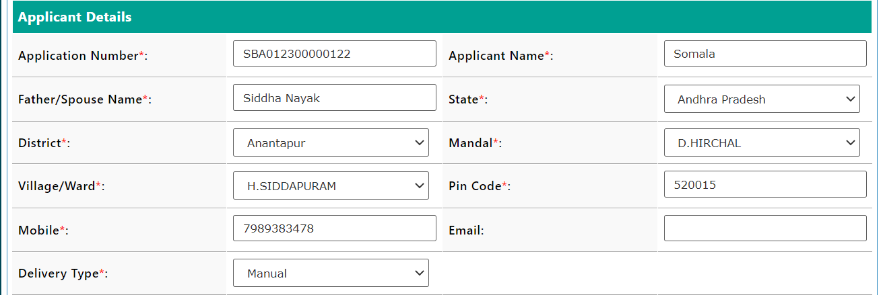

Figure 11: Applicant details

- Upload the required documents and select on show payment option as depicted in figure 12.

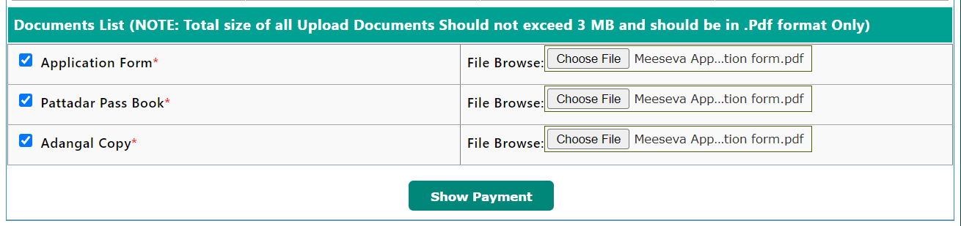

Figure 12: Show Payment
- A list of charges will appear and select on confirm payment as depicted in figure 13.

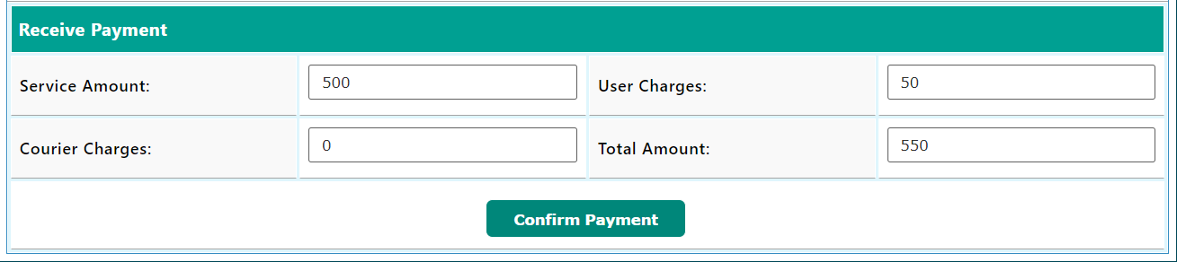

Figure 13: Confirm payment

- A receipt will be generated as depicted in figure 14.

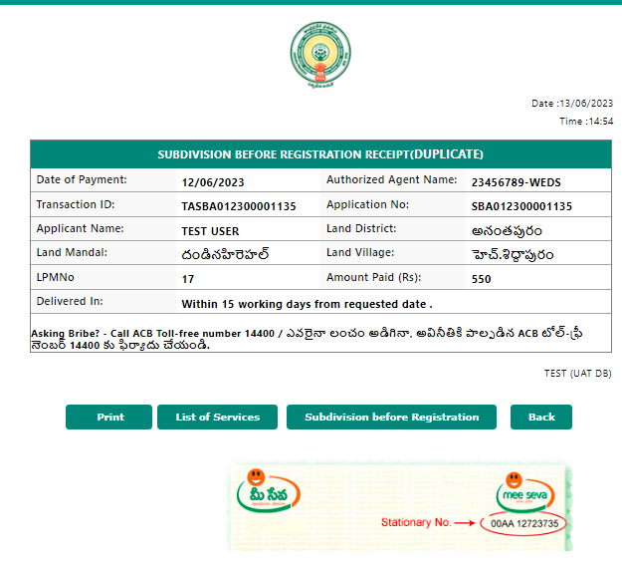

Figure 14: Receipt

Note: After generating the request, A SMS confirmation will be sent to applicant. The application request will be sent to respective VILLAGE SURVEYOR. VILLAGE SURVEYOR will do a ground survey and will forward to MANDAL SURVEYOR and Tahsildar, based on the application and remarks given by VILLAGE SURVEYOR, MANDAL SURVEYOR and Tahsildar will only view the application.

Department Process Flow:
VILLAGE SURVEYOR>>> MANDAL SURVEYOR>>>TAHSILDAR

VILLAGE SURVEYOR Process:
- Go to MeeSeva portal as depicted in figure 1.
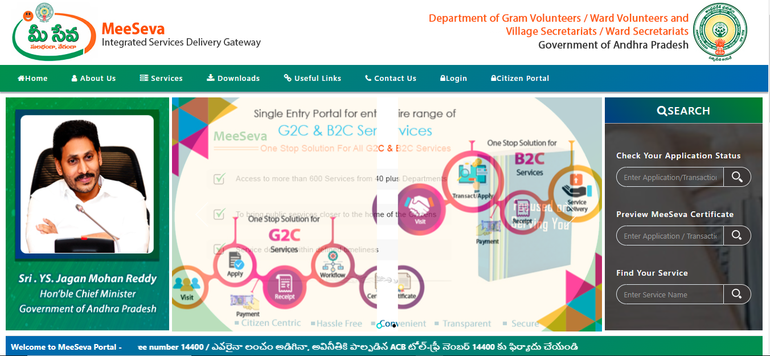

Figure 1: MeeSeva website
- Select Login as depicted in figure 2.

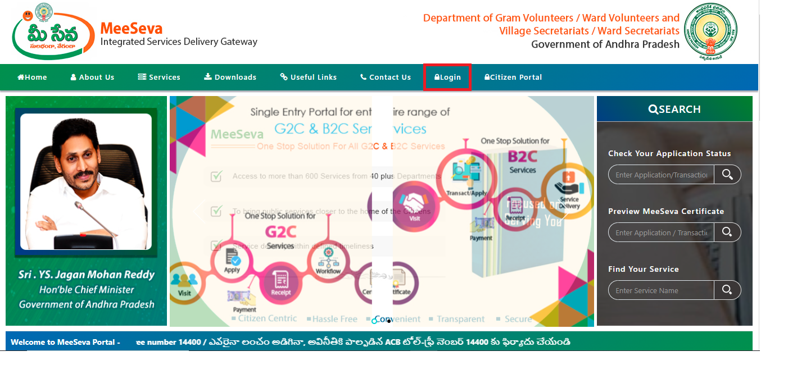

Figure 2: Selecting Login

- Enter Login id and password and select on login as depicted in figure 3.
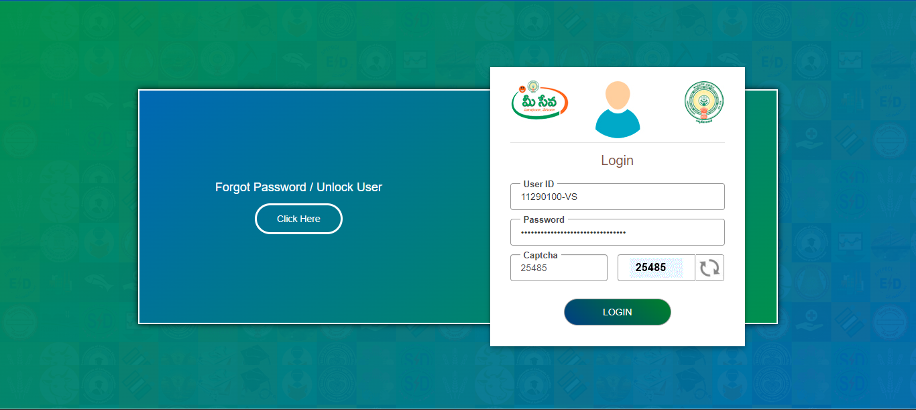

Figure 3: Login and Password
- Select Online Sub Division service as depicted in figure 4.
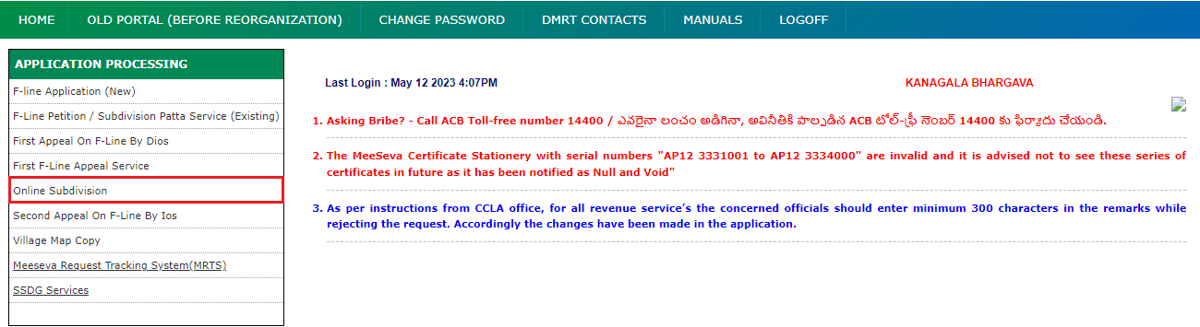

Figure 4: Login and Password
- In search criteria enter from date, to date and request status details as depicted in figure 5.
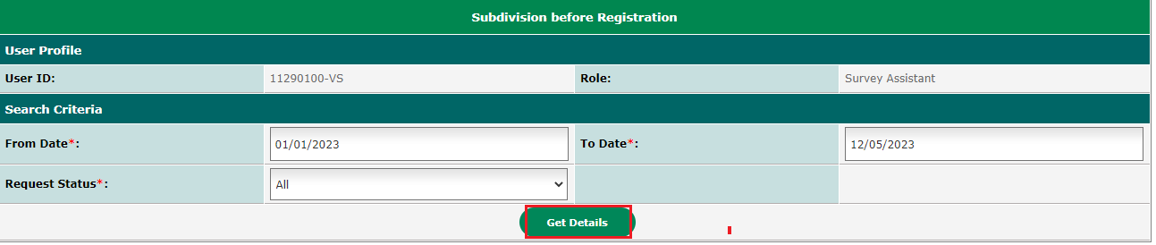

Figure 5: Search criteria

- A list request appplication will appear Village Surveyor wil select based on the requirement of application as depicted in figure 6.
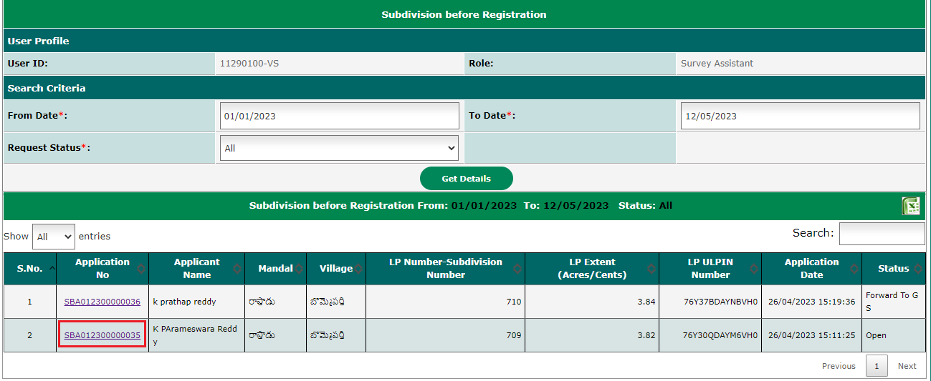

Figure 6: List of application

- After clicking on application number service request details will appear as depicted in figure 7.
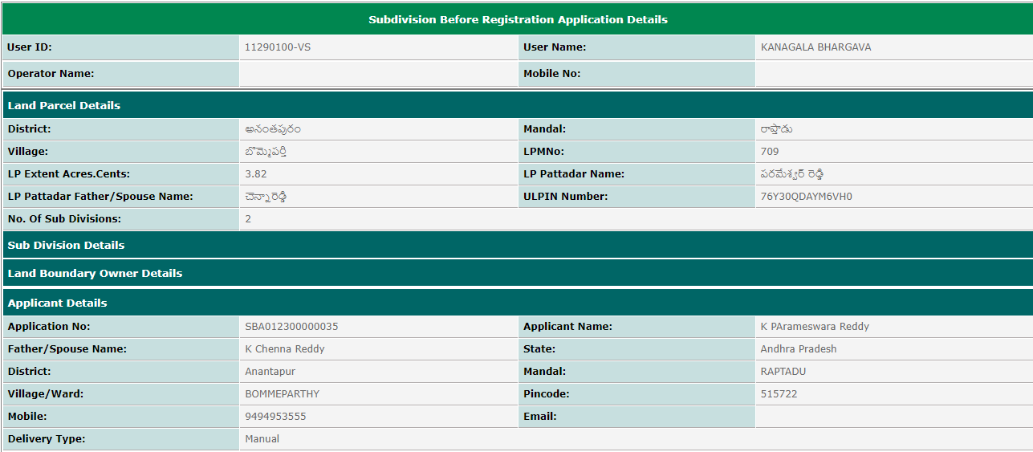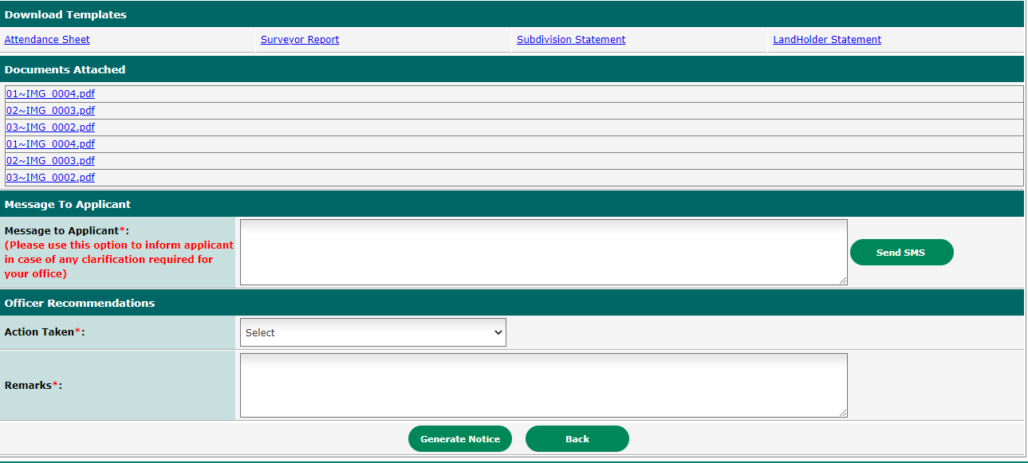

Figure 7: Service request details

- Here Village Surveyor can download the documents and can verify them. VILLAGE SURVEYOR has porvision to download the templates before going to ground survey as depicted in figure 8.
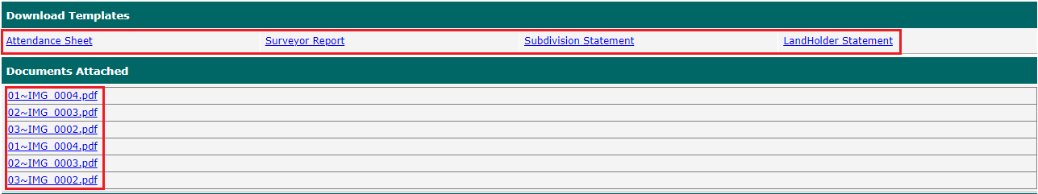

Figure 8: Documents

- A message will be sent to applicant when ground survey is done as depicted in figure 9.

Figure 9: Message to applicant

- Now notice will be generated by selecting Generate Notice in action taken option, Village Surveyor enters remarks and selects Generate Notice option as depicted in figure 10.
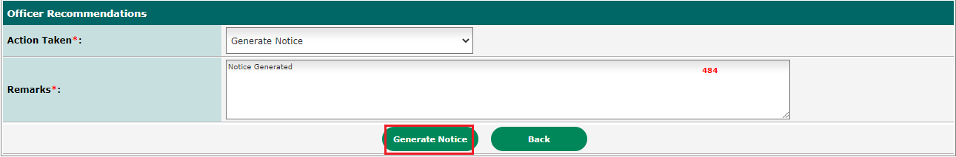

Figure 10: Notice generation
- After that a pop up will appear where date and time should be entered and select on Generate option as depicted in figure 11.
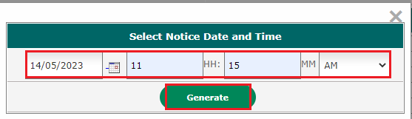

Figure 11: Notice generation Date and Time

- The notice generated is below as depicted in figure 12.

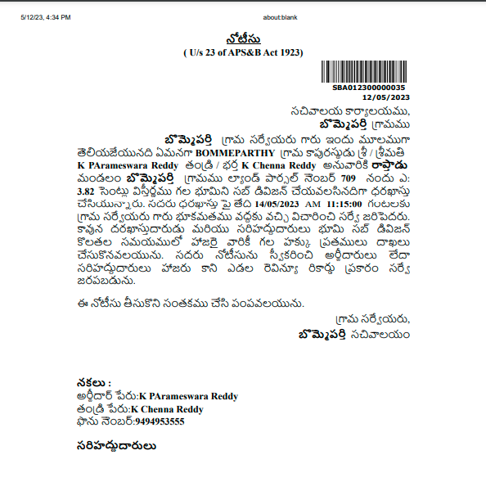

Figure 12: Notice

- After generation of notice VILLAGE SURVEYOR will select Forward to GS or Regenerate Notice based on the application in action taken section as depicted in figure 13.
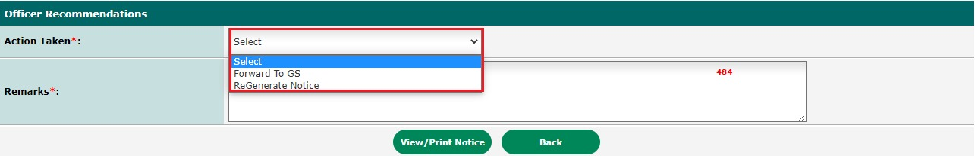

Figure 13: Action Taken

- A ground survey will be conducted in offline method and the respective documents will be given to VILLAGE SURVEYOR with an acknowledgment copy.
- VILLAGE SURVEYOR will upload these documents in VILLAGE SURVEYOR Login by selecting Upload document options as depicted in figure 14.
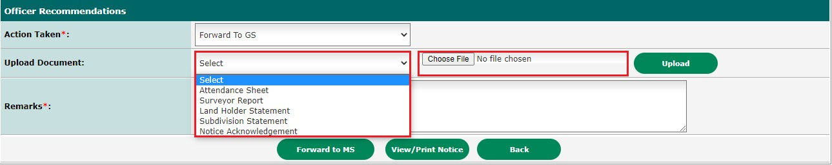

Figure 14: Documents Upload section in VILLAGE SURVEYOR Login
- After that VILLAGE SURVEYOR will be selecting the document select Upload option as depicted in figure 15.
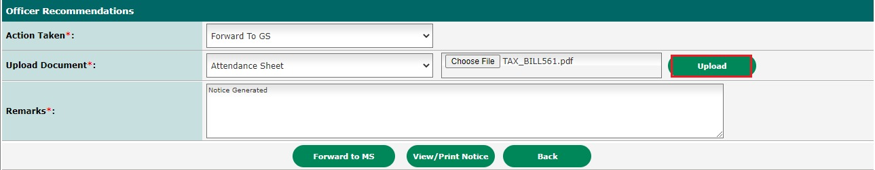

Figure 15: Upload procedure
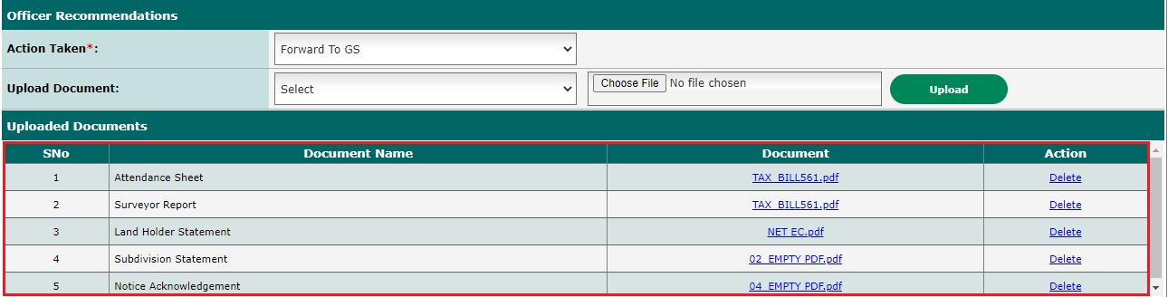
- After uploading all the documents a preview will appear as depicted in figure 16.

Figure 16: Document Preview

- After that VILLAGE SURVEYOR will enter the remarks and select on forward to MANDAL SURVEYOR option as depicted in figure 17.
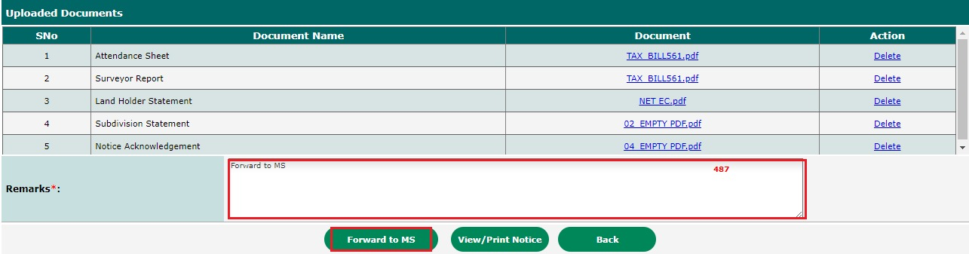

Figure 17: Remarks and Forward to MANDAL SURVEYOR option
- After that a message will appear Application generated successfully as depicted in figure 18.
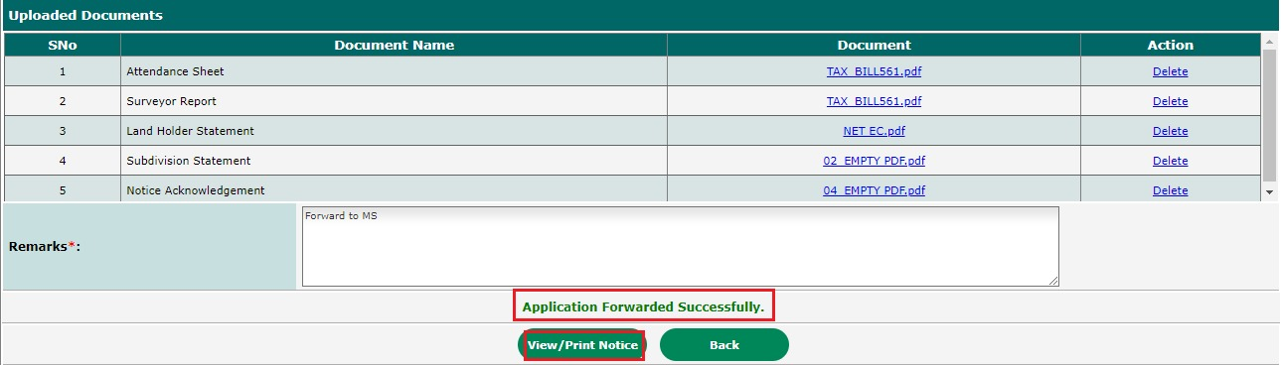

Figure 18: Message preview

- VILLAGE SURVEYOR Forward the Applications to Mandal Surveyor & Tahsildar at a time. Mandal Surveyor & Tahsildar can view the application details and notice generation on documents.

MANDAL SURVEYOR Process
- Go to MeeSeva portal as depicted in figure 19.

Figure 19: MeeSeva website
- Select Login as depicted in figure 20.

Figure 21: Selecting Login

- Enter Login id and password and select on login as depicted in figure 22.
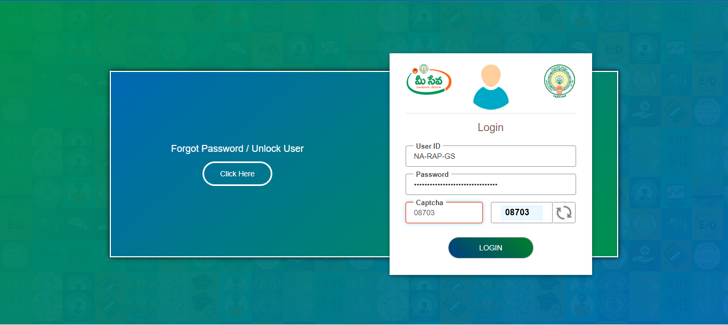

Figure 22: Login and Password
- Select online subdivision service as depicted in figure 23.
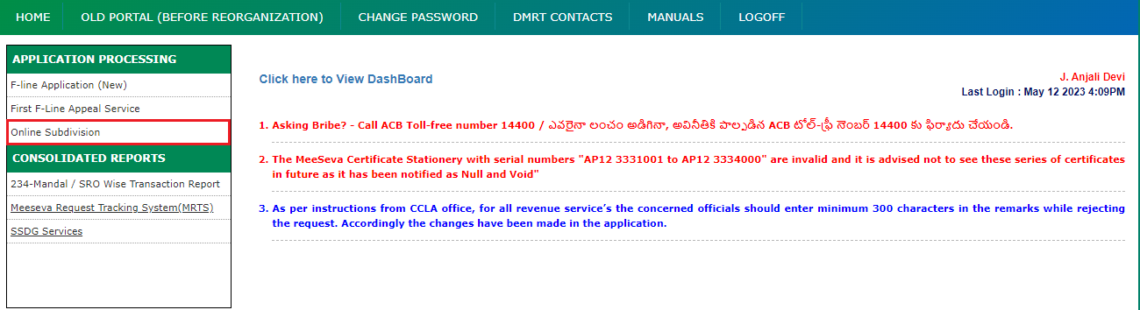

Figure 23: Login and Password
- In search criteria enter from date, to date and request status details as depicted in figure 24.
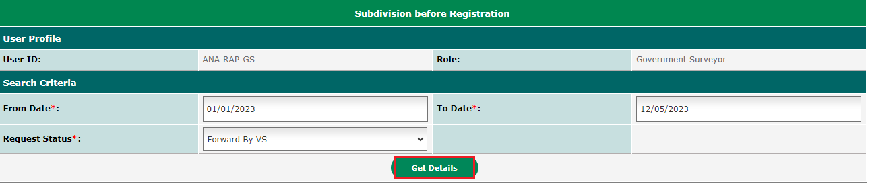

Figure 24: Search Criteria

- A list request appplication will appear Village Surveyor wil select based on the requirement of application as depicted in figure 25.
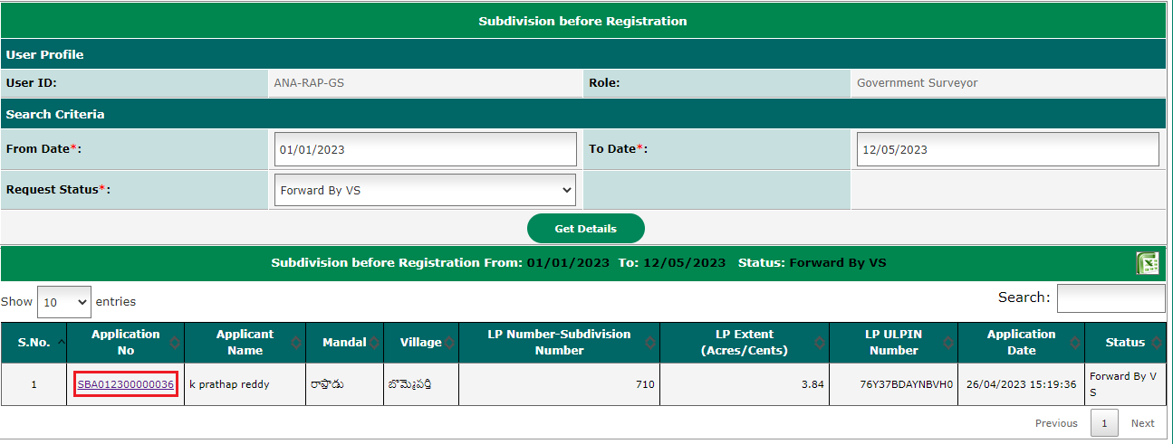

Figure 25: List of applications
- After clicking on application number service request details will appear as depicted in figure 26.
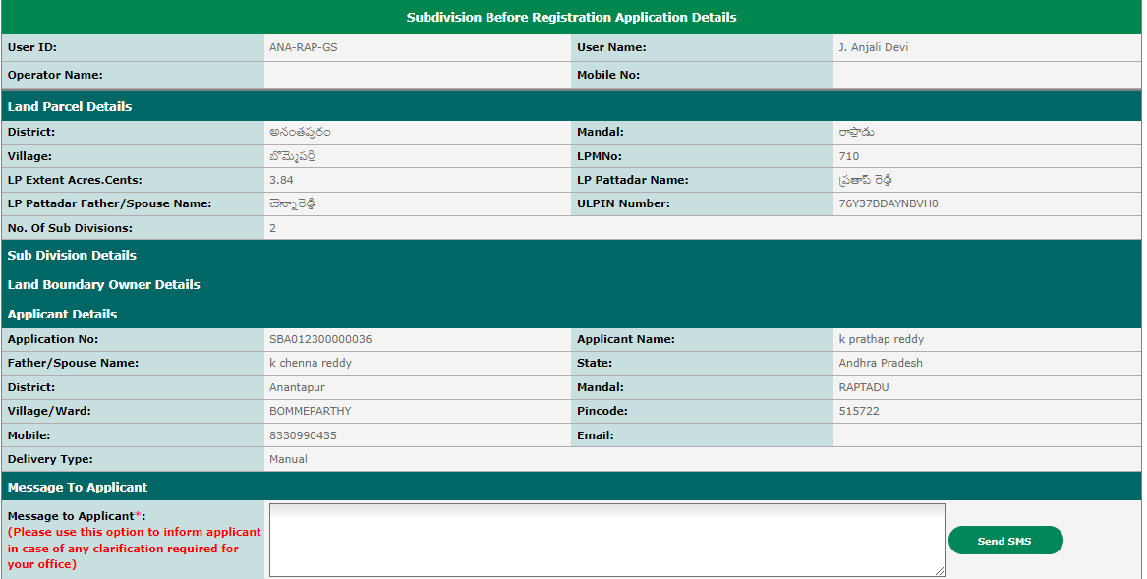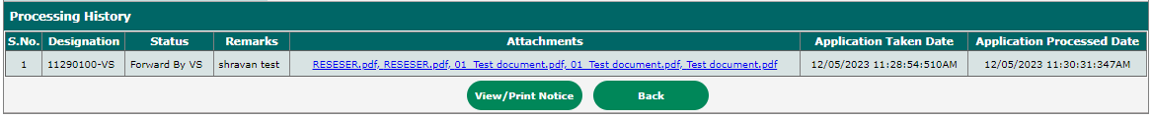

Figure 26: Service Request Details

- MANDAL SURVEYOR can only verify the details.

Tahsildar Process
- Go to MeeSeva portal as depicted in figure 27.

Figure 27: MeeSeva website
- Select Login as depicted in figure 28.

Figure 28: Selecting Login

- Enter Login id and password and select on login as depicted in figure 29.
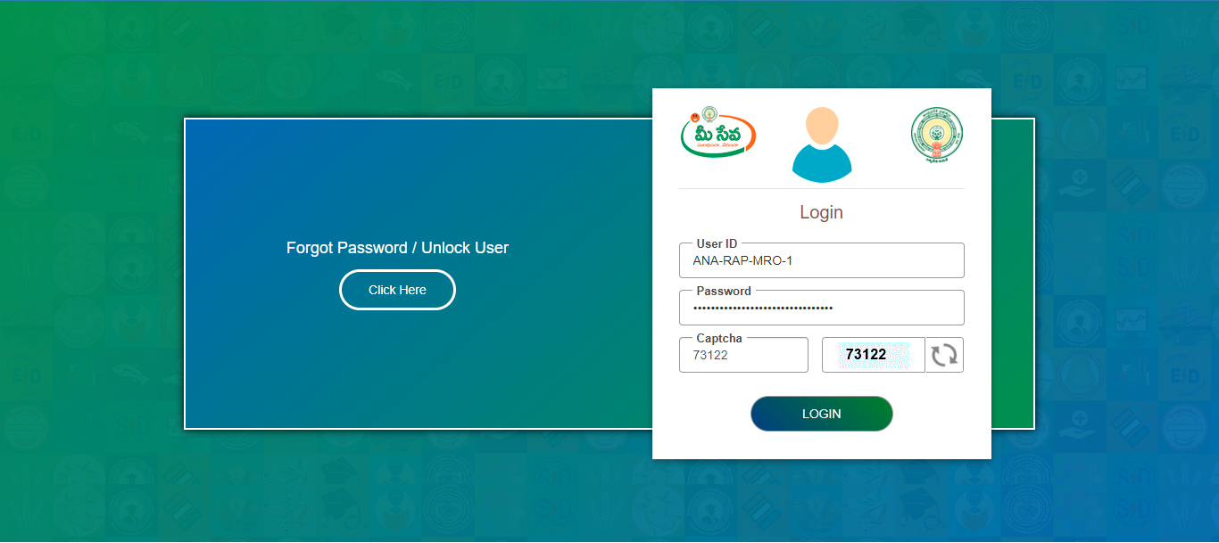

Figure 29: Login id and password

- Select online subdivision service as depicted in figure 30.
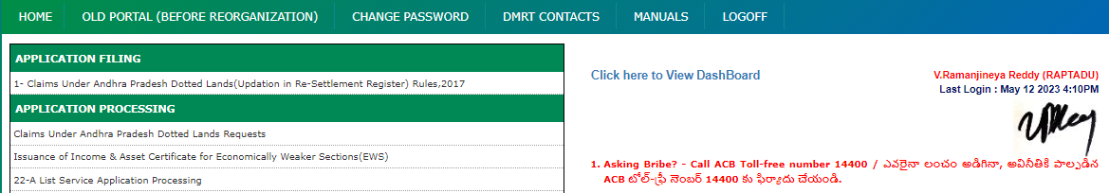

Figure 30: Selection of service
- In search criteria enter from date, to date and request status details as depicted in figure31.
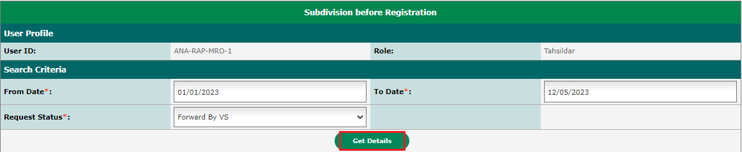

Figure 31: Search Criteria

- A list request appplication will appear Village Surveyor wil select based on the requirement of application as depicted in figure 32.
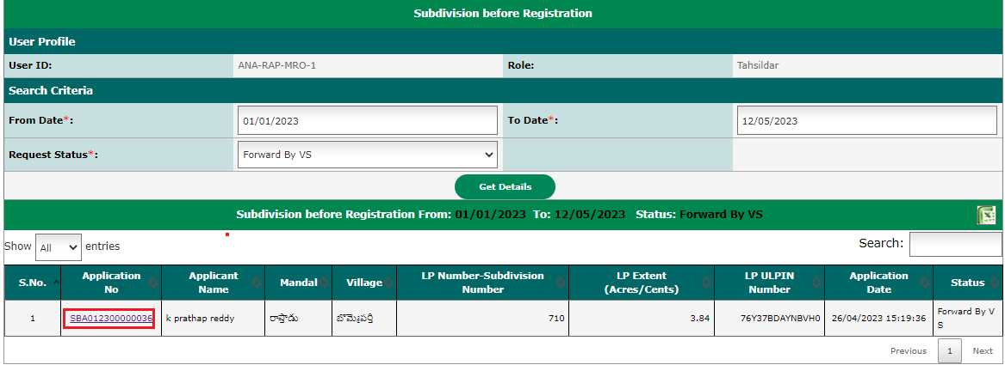

Figure 32: List of applications
- After clicking on application number service request details will appear as depicted in figure 33.
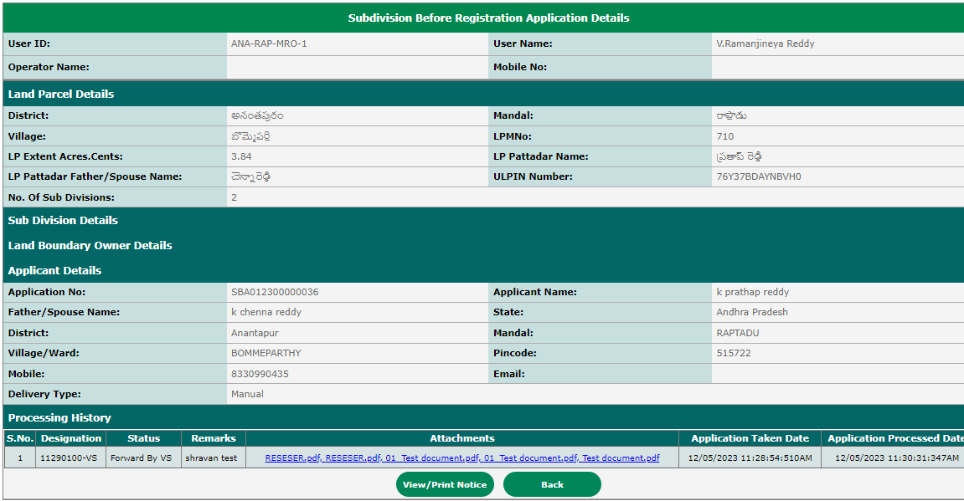

Figure 33: Service Request Details

- Tahsildar can only verify the details.
Note: When the applicant request is delivered to Bhunaksha via the API, Bhunaksha creates the LPM Shape File based on the applicant's information. Based on the field survey report, Bhunaksha Tahsildar shares the LPM Shape File. Webland Tahsildar receives the file from Bhunaksha Tahsildar. Webland Tahsildar verifies the LPM Shape file sent by Bhunaksha tahsildar and then creates the proceedings after logging into the Webland portal. Citizens collect the proceeding copy and LPM shape PDF file from GSWS Centers through API.

Process Flow Chart
